Eyeconic - Glasses Shop Management System

Edit Cloths

Version <1.0>

Revision History

|  |  |  |  |
| --- | --- | --- | --- |
| **Date** | **Version** | **Description** | **Author** |
| <06/11/2019> | <1.0> | Start creating use case | Nguyễn Tuấn Anh |
|  |  |  |  |

Table of Contents

1. Edit Cloths 4

1.1 Brief Description 4

1.2 Basic Flow 4

2.2 Exception 5

2.2.1 Edit Cloths 5

2.2.2 Fill in the Cloths information 5

2. Special Requirements 5

3. Preconditions 5

4. Postconditions 5

5. Extension Points 5

Use-Case Specification: Edit Cloths

# Edit Cloths

## Brief Description

This use case defines the step of update existing Cloths

Cloths are updated by the admin.

## Basic Flow

The system administration selects the Cloths data to edit. The administrator changes the information. The system displays the updated management parameter value and logs the change

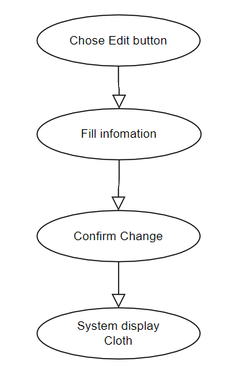

***Basic flow of Editing Cloths***

Step 1: Choose the Cloths you want to edit

Step 2: Click edit button

A modal view shows up

Edit the information.

Step 3: Confirming editing the Cloths by clicking the “Save” button.

Step 4: Successful information changed Cloths are displayed on the screen

## 2.2 Exception

### 2.2.1 Edit Cloths

The edit button cannot be clicked or isn’t appeared on the screen

### 2.2.2 Fill in the Cloths information

Invalid information.

2.2.3 Confirming editing the Cloth

The “Save” button is clicked but the new information of the Cloths are not changed.

2.2.4 System displays edited Cloth

The edited Cloth’ information are not display correctly.

# Special Requirements

# Preconditions

User must already login as the administrator of the website.

# Postconditions

Cloth information is changed and can be purchased by customers.

# Extension Points

Administrator check the website and the system to ensure that the edited information of the Cloths is correct.